PROJECT 1
Connecting to Cloud SQL: Compute Engine, Private IP and Cloud SQL Proxy
1. Introduction
Modern cloud applications require secure and efficient communication between application servers and databases. Google Cloud SQL is a fully managed relational database service that simplifies database administration while providing scalability, security, and high availability.
In this project, we established a secure connection between a Compute Engine virtual machine and a Cloud SQL instance. Instead of exposing the database over the public internet, the connection was configured using Private IP networking and the Cloud SQL Auth Proxy. This approach ensures that database traffic remains within Google's private network, significantly improving security and reducing exposure to external threats.
The project demonstrates how cloud networking, virtual machines, and managed databases can work together to build secure enterprise-grade applications.

2. Theory
Google Compute Engine
Google Compute Engine (GCE) provides Infrastructure as a Service (IaaS), allowing users to create and manage virtual machines on Google Cloud.
It offers:
- Virtual machines
- Custom machine configurations
- Persistent storage
- Network management
- High availability
Applications usually run on Compute Engine instances while storing their data inside Cloud SQL.
Cloud SQL
Cloud SQL is Google's managed relational database service supporting:
- MySQL
- PostgreSQL
- SQL Server
Features include:
- Automatic backups
- Failover support
- Scaling
- Security patches
- Monitoring
Private IP Connectivity
Normally databases can be accessed through Public IP.
However, Public IP:
- exposes the database
- increases attack surface
- requires firewall configuration
Private IP solves this by:
- keeping traffic inside Google's VPC
- improving security
- lowering latency
- enabling enterprise networking
Cloud SQL Auth Proxy
Cloud SQL Proxy acts as a secure intermediary.
Instead of directly connecting to the database:
Application
↓
Cloud SQL Proxy
↓
Cloud SQL Instance
Benefits:
- IAM Authentication
- Encrypted communication
- No SSL certificate management
- Secure authentication

3. Tech Stack
Cloud Platform
- Google Cloud Platform (GCP)
Services Used
- Compute Engine
- Cloud SQL
- VPC Network
- Cloud SQL Auth Proxy
- IAM
- Private Service Access
Database
- MySQL
Operating System
- Linux VM
Networking
- Private IP
- VPC

4. What We Actually Did
The project began by creating a Compute Engine virtual machine that would act as the application server.
Next, a Cloud SQL MySQL instance was created.
Instead of enabling Public IP connectivity, Private Service Access was configured to assign a Private IP to the Cloud SQL instance.
The VM and Cloud SQL were placed inside the same VPC network.
The Cloud SQL Auth Proxy was then downloaded and installed on the Compute Engine instance.
After configuring the required IAM permissions, the proxy established an authenticated encrypted tunnel between the VM and the Cloud SQL database.
Finally, SQL commands were executed successfully to verify the connection.
The database was accessed without exposing it to the public internet.

5. Mistakes Faced and Fixes
Problem 1
Private IP connection failed.
Reason
Private Service Access was not configured correctly.
Fix
Configured VPC peering and enabled Private Service Access before creating the Cloud SQL instance.

Problem 2
Cloud SQL Proxy authentication failed.
Reason
Compute Engine lacked the required IAM permissions.
Fix
Granted Cloud SQL Client role to the VM service account.

Problem 3
Database connection timed out.
Reason
Incorrect network configuration.
Fix
Verified firewall rules and ensured both resources belonged to the same VPC.

Problem 4
Proxy did not start.
Reason
Incorrect instance connection name.
Fix
Copied the exact instance connection name from Cloud SQL settings.

6. Real-Life Applications
This architecture is widely used in:
- Banking systems
- Healthcare applications
- Enterprise ERP systems
- Government applications
- Internal company dashboards
- SaaS platforms
- E-commerce backends
Private networking and Cloud SQL Proxy help organizations maintain strong security while ensuring reliable database communication.

SYSTEM DESIGN
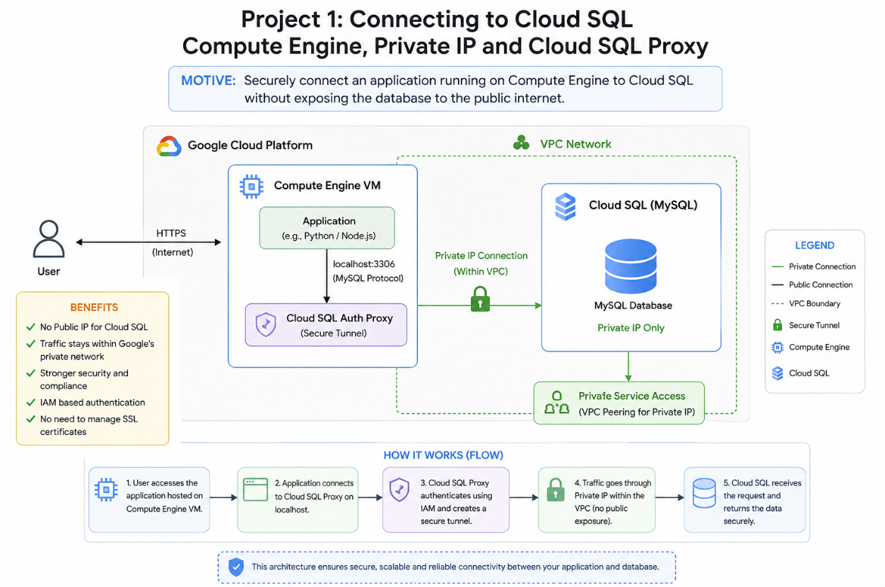

PROJECT 2
Google Cloud MCP for AlloyDB for AI Agents
1. Introduction
The emergence of Large Language Models (LLMs) has transformed how applications interact with data. However, AI models often struggle to access live enterprise databases securely. Google's Model Context Protocol (MCP) provides a standardized method for AI agents to communicate with external systems such as databases and APIs.
In this project, we integrated AlloyDB with MCP, enabling AI agents to query structured enterprise data efficiently and securely. The implementation demonstrated how AI systems can retrieve real-time database information while maintaining enterprise-grade security and scalability.

2. Theory
AlloyDB
AlloyDB is Google's high-performance PostgreSQL-compatible database designed for AI-powered applications.
Features:
- PostgreSQL compatibility
- High availability
- Automatic backups
- AI integration
- Vector search support
- Low latency
Model Context Protocol (MCP)
MCP is an open protocol that standardizes communication between AI models and external tools.
Instead of giving AI direct database access:
AI Agent
↓
MCP Server
↓
AlloyDB
This architecture improves security and flexibility.
AI Agents
AI agents are autonomous software systems capable of:
- reasoning
- planning
- tool usage
- database querying
- workflow automation

3. Tech Stack
Cloud Platform
- Google Cloud Platform
Database
- AlloyDB
Services
- MCP Server
- IAM
- AlloyDB
- Vertex AI integrations
Programming
- Python
Database Language
- SQL

4. What We Actually Did
We provisioned an AlloyDB cluster and configured the required networking and IAM permissions.
Next, the MCP server was deployed and connected to the AlloyDB instance.
The server exposed database operations as standardized MCP tools.
An AI agent was configured to communicate with the MCP server instead of directly accessing the database.
The AI agent successfully executed SQL queries through MCP and retrieved structured information.
The interaction demonstrated secure AI-to-database communication using Google's AI infrastructure.

5. Mistakes and Fixes
Problem 1
Agent could not detect MCP server.
Fix
Verified server endpoint configuration.

Problem 2
Database authentication failed.
Fix
Updated AlloyDB credentials and IAM permissions.

Problem 3
SQL query execution errors.
Fix
Corrected SQL syntax and verified table names.

Problem 4
Network timeout.
Fix
Ensured AlloyDB cluster networking and firewall configuration were correct.

6. Real-Life Applications
- AI customer support
- Financial analytics
- Healthcare assistants
- HR management
- Supply chain optimization
- AI-powered dashboards
- Business intelligence systems
- Enterprise data assistants

SYSTEM DESIGN
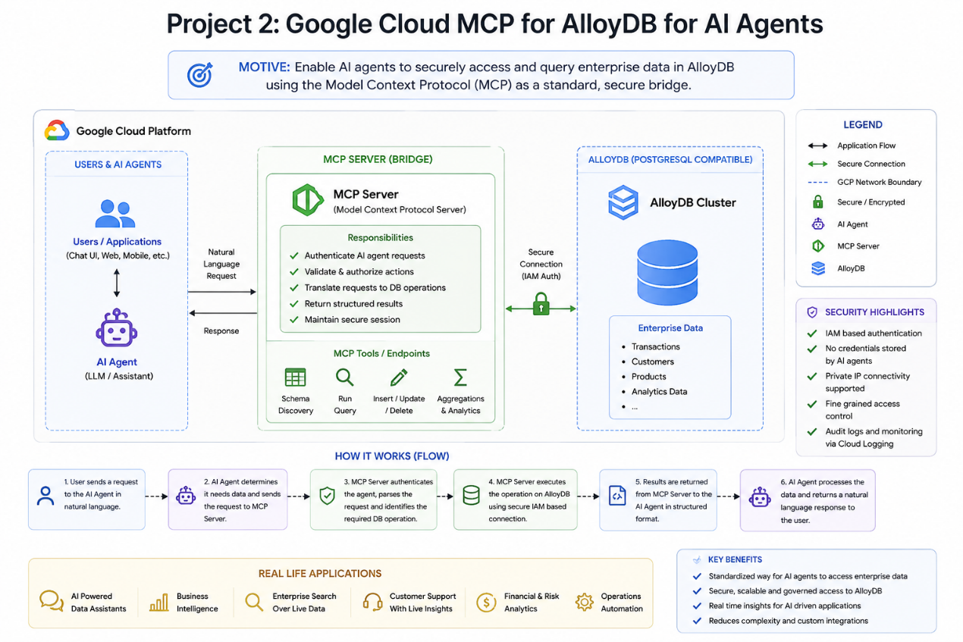

PROJECT 3
Build a Multi-agent App with MCP Toolbox for AlloyDB & ADK
1. Introduction
Modern AI applications increasingly rely on multiple specialized agents working together rather than a single monolithic model. Google's Agent Development Kit (ADK) and MCP Toolbox enable developers to build collaborative AI systems where each agent performs a specific task while securely accessing enterprise databases through AlloyDB.
In this project, we built a multi-agent application using the MCP Toolbox, AlloyDB, and Google's Agent Development Kit. The system demonstrated coordinated task execution, allowing multiple AI agents to access structured data, perform reasoning, and deliver accurate responses through standardized MCP interfaces.

2. Theory
Agent Development Kit (ADK)
ADK provides tools for building AI agents capable of:
- planning
- reasoning
- tool calling
- workflow execution
- multi-agent collaboration
MCP Toolbox
The MCP Toolbox manages communication between AI agents and external tools.
It offers:
- tool discovery
- request routing
- standardized APIs
- secure execution
Multi-agent Systems
Instead of one AI handling everything:
User
↓
Coordinator Agent
↓
Database Agent
↓
Reasoning Agent
↓
Response Agent
Each agent specializes in a different responsibility, improving accuracy, scalability, and maintainability.

3. Tech Stack
Cloud Platform
- Google Cloud Platform
Database
- AlloyDB
AI Framework
- Google Agent Development Kit (ADK)
Protocol
- Model Context Protocol (MCP)
Programming
- Python
Database
- PostgreSQL (AlloyDB)
Tools
- MCP Toolbox
- IAM
- Cloud Shell

4. What We Actually Did
We configured the AlloyDB database and connected it to the MCP Toolbox.
The Agent Development Kit was used to create multiple AI agents with distinct roles, such as query execution, reasoning, and response generation.
Each agent communicated through the MCP Toolbox, which managed tool invocation and database access.
The coordinator agent distributed incoming requests to the appropriate specialized agent. Database queries were executed against AlloyDB, and the retrieved information was processed before being returned to the user.
The completed application demonstrated secure multi-agent collaboration using Google's AI infrastructure.

5. Mistakes and Fixes
Problem 1
Agents failed to communicate.
Fix
Verified MCP Toolbox configuration and agent registration.

Problem 2
Tool invocation failed.
Fix
Corrected tool configuration and ensured proper permissions.

Problem 3
Database queries returned no data.
Fix
Validated database schema, table names, and SQL queries.

Problem 4
Authentication issues.
Fix
Configured IAM roles and authenticated the environment using Google Cloud credentials.

6. Real-Life Applications
Multi-agent AI systems built with ADK, MCP Toolbox, and AlloyDB can be applied to:
- Enterprise AI assistants
- Automated customer service
- Intelligent banking systems
- Healthcare decision-support platforms
- Legal document analysis
- Research assistants
- Smart manufacturing and logistics
- AI-driven business process automation

SYSTEM DESIGN
